Database Systems Lab Assignment 8

Name = Poorab Gangwani

Class = 4B1

Roll-Number = CS191092

1. Display the name, designation, and salary of the highest paid employee without using the ORDER BY clause.

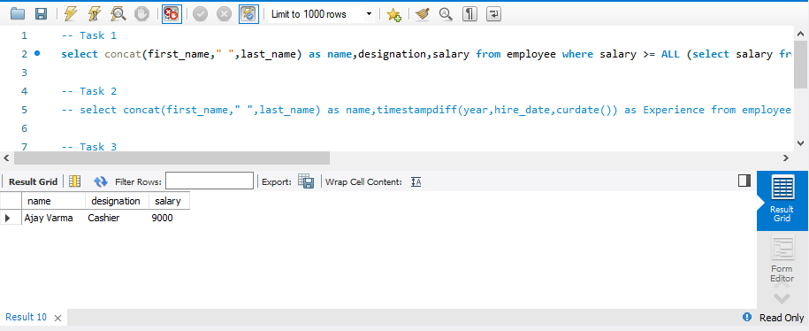

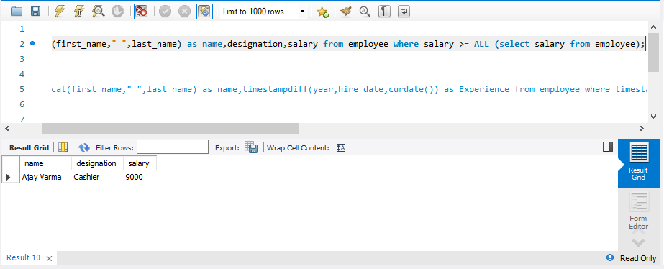

2. Display the name and experience of the employee with the maximum experience.

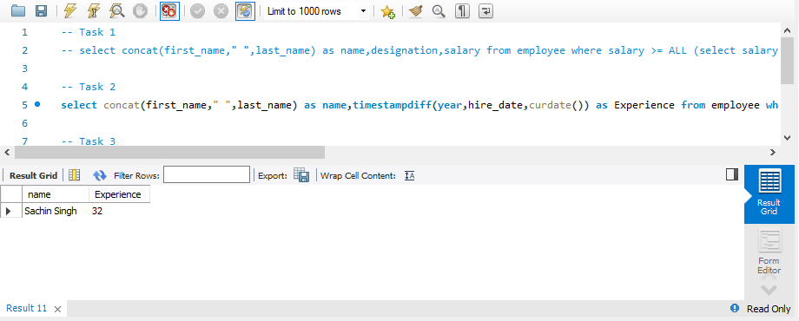

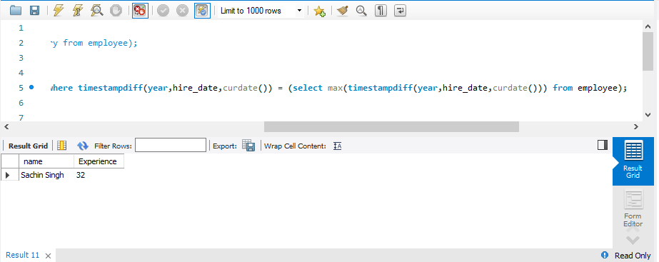

3. Display the names and salaries of all the employees whose salary is greater than the average salary of the company.

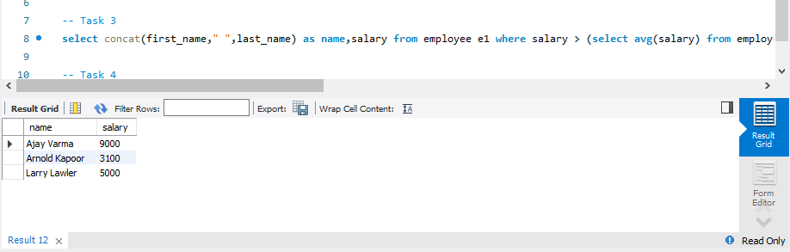

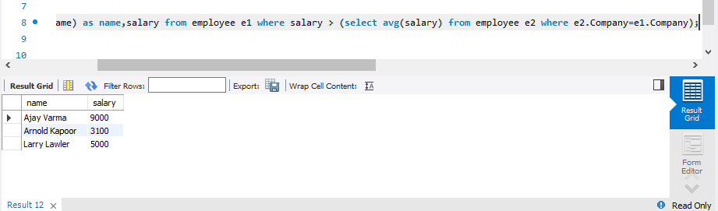

4. Display the highest paid employee of each department.

